**PROJEKTDOKUMENTATION**BATTLESHIP - THE GAME

**Course :**  SWENGB  
**Supervisor:** Dipl.-Ing. Robert Ladstätter  
**Due date**: January 25th, 2018  
  
**Team Name:** Die fantastischen Vier  
**TeamID:** Vier  
**Authors:** Arneitz Jakob  
 Rinnhofer Thomas  
 Ruggenthaler Benjamin  
 Wallner Barbara

# Table of Content

1. INTRODUCTION 3

1.1 Project Definition 3

1.2 Features (Implementation) 3

1.2.1 Startup / Splash Screen 3

1.2.2 Welcome screen 3

1.2.3 Credits screen 4

1.2.4 Start a new game 4

1.2.5 Naming of battles 4

1.3 Placing the ships ('Edit mode') 4

1.4 Game Flow 4

1.5 Displaying status 4

1.6 Game over 4

1.7 High score 4

2. Project structure 5

2.1 Project team 5

2.2 Time estimation 5

2.2.1 Design 5

2.2.2 Development 5

2.2.3 Testing 5

2.2.4 Planning 5

2.2.5 Documentation 5

2.2.6 Overview of costs 6

2.3 Planned work items 6

2.3.2 Work package 2 6

2.3.3 Work package 3 6

2.3.4 Work package 4 6

2.3.5 Work package 5 6

2.3.6 Work package 6 6

3. Mock up 7

# 1. INTRODUCTION

## 1.1 Project Definition

In our project assignment we will continue to work on our battleship codebase. We will implement new features and try to polish the application in order to reach nice looking, playable battleship simulation.

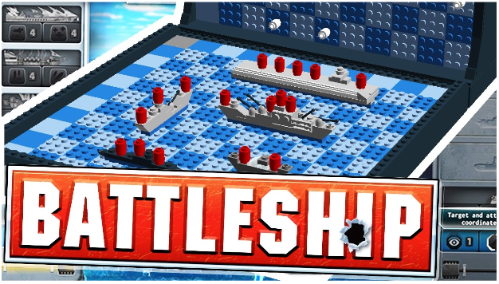

## 1.2 Features (Implementation)

Every team has to implement a multiplayer mode for battleship. That means that there are two players who are playing against each other. The game is round based, this means only one player is active at a time.

The team can implement their Multiplayer mode in various ways. For example:  
  
 ► You start two instances of the application, and both instances synch themselves via   
 probuff files. Both instances of the app have to have file access to the proto files.  
 ► Another alternative is that you duplicate the battlefield for player A and player B.  
 ► A third alternative would be to stay with one battlefield, but switch for every turn   
 (one time display data for player A, then again for player B).

### 1.2.1 Startup / Splash Screen

On startup of your application, you should show a nice image which contains the application name.

### 1.2.2 Welcome screen

After starting the game, you should be displayed a menu comprising:

► Start a new game  
 ► Show highscore  
 ► Show credits

### 1.2.3 Credits screen

A screen where you should place information about the authors and the distribution license you've chosen.

### 1.2.4 Start a new game

It should be possible to start a new game after startup. The app should ask about the player names and use them thereafter. For example, each player name should be displayed in their corresponding view / region on the screen.

### 1.2.5 Naming of battles

Each battle gets its own name. This name is prefilled in a Textbox. The name should be randomly created from a list of base names. For example:

## 1.3 Placing the ships ('Edit mode')

Somehow it has to be possible to place the ships, that it has to be possible to select the ship type and the position of the ship. A nice visual feedback for placing ships should be implemented. After placing the fleet for one player, player B should be able to do the same for his fleet.

## 1.4 Game Flow

After fleet positions are defined for both players, it should be possible to start the game. Game start means that player A is active, he can see where he already tried to hit the opponent's fleet (either successfully or not). When control switches back to player b, he as well can see his game state.

## 1.5 Displaying status

Somewhere on your screen there should be a statistic which ships are part of the game, which ship is already hit. Think about displaying graphics which represent the state of your fleet on a dedicated region of your screen. It should look like a game.

## 1.6 Game over

The game should be able to detect when a battleship was hit, or when a ship was sunk. If all ships were hit, the game is over, the high score screen is displayed with a new entry. The entry is sorted according to the needed moves to destroy the enemy fleet.

## 1.7 High score

After a battle has ended, a high score is displayed. The high score should consists of following elements:

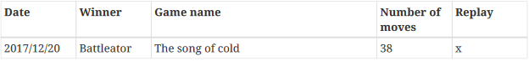

High score should be persistent, that means it should be saved to disc. On the start of the application, it can be loaded. Clicking on the 5th column should load an old game again and you can replay the game.

# 2. Project structure

## 2.1 Project team

The project team consists of four students. Each student should be aware of all code involved but it is advisable to partition the work so every team member is responsible for a different task. Our methodology is SCRUM.

►Team name: die fantastischen Vier  
 ► TeamID: Vier

|  |  |
| --- | --- |
| STUDENT | ROLE |
| Arneitz Jakob | Concept, Design |
| Rinnhofer Thomas | Concept, Development |
| Ruggenthaler Benjamin | Concept, Testing |
| Wallner Barbara | Concept, Documentation |

## 2.2 Time estimation

### 2.2.1 Design

►Due date: January 14th, 2018  
 ►Costs:20h à 13€/h  
 ►Result: five screens

### 2.2.2 Development

►Due date: January 14th, 2018  
 ►Costs: 30h à 16€/h  
 ►Result: working code

2.2.3 Testing   
 ►Due date: January 22th, 2018  
 ►Costs: 6h à 13€/h  
 ►Result: testing functionality

2.2.4 Planning  
 ►Due date: January 5th, 2018  
 ►Effort: 20h  
 ►Result: finish concept; roles; workpackages

2.2.5 Documentation   
 ► Due date: January 14th, 2018  
 ►Effort: 10h  
 ►Result: finished documentation

### 2.2.6 Overview of costs

|  |  |
| --- | --- |
| EFFORT | COSTS |
| Design | 260,- |
| Development | 480,- |
| Testing | 78,- |
| Planning | - |
| Documentation | - |
| TOTAL | **818,-** |

2.3 Planned work items   
2.3.1 Work package 1   
 ► Implementation of the first screen

2.3.2 Work package 2  
 ► Implementation of the second screen

2.3.3 Work package 3  
 ► Implementation of the third screen

2.3.4 Work package 4  
 ► Implementation of the fourth screen

2.3.5 Work package 5  
 ► Implementation of the fifth screen

2.3.6 Work package 6  
 ► Start coding

# 3. Mock up

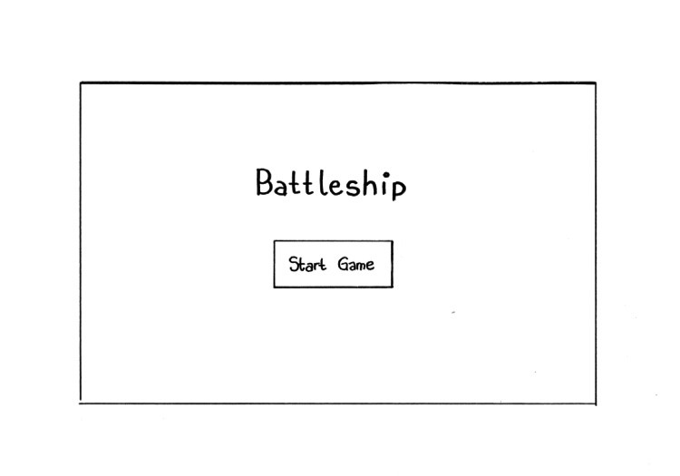If you start the game this is the first screen that appears. It contains the name of the game (Battleship) and by clicking "Start Game" the next screen appears.

Now you can choose between three options:

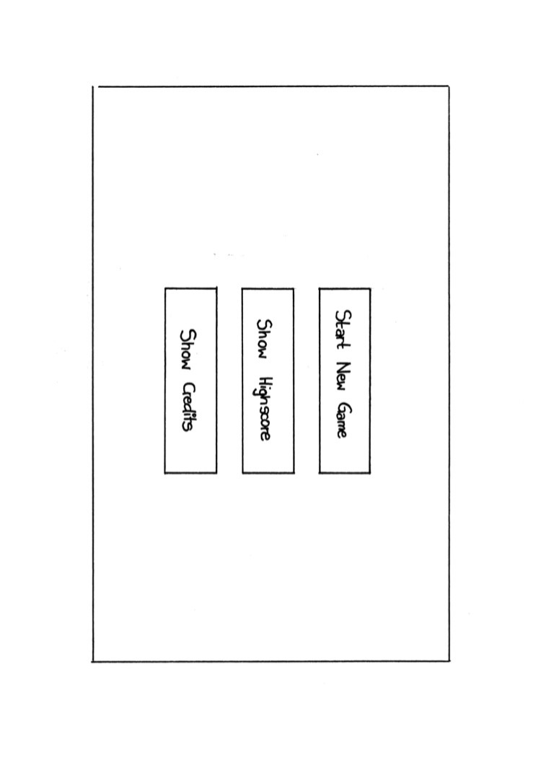 ►Start New Game: starts a new Battleship game   
 ► Show Highscore: get the highscore of your previous games  
 ► Show Credits: information about the authors, sources and license

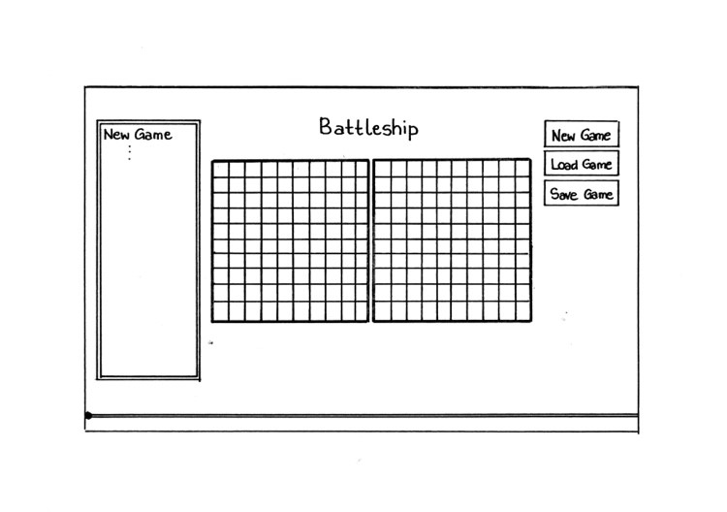Now, you can place your ships and play the game. On the left site there is a box where every hit, click and so on is documented. On the right site there are three buttons "New Game", "Load Game" and "Save Game". These buttons are additional features to load an old game, save the current one or to play a new game. And of course, there is also the "Slider" function to have a look at previous games.

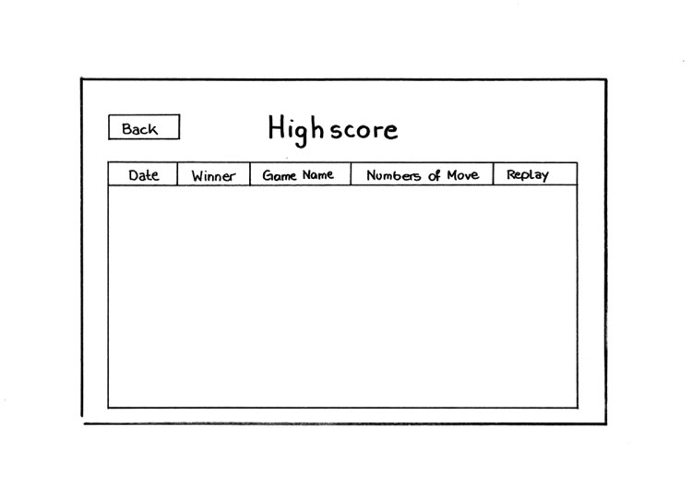By clicking the "Save Game" button you automatically come to the Highscore screen. This screen shows details about the played game (date, winner, game name, numbers of move and replay). To get back to the screen where you can choose between playing a new game, showing the credits etc. you only have to click the "Back" button.

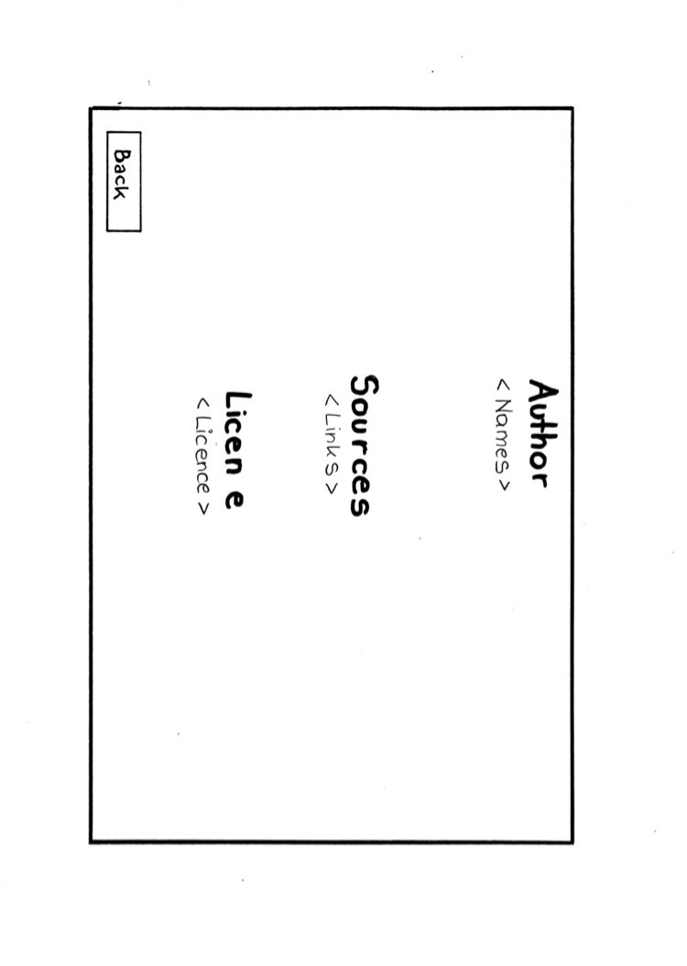To get more information about the authors, the sources or the license about the game just click "show credits". Of course, there is also a "Back"-button to get back to the main menu.

**s**

**s**

Changes might occur during coding!

# 4. Manual

## 4.1 Start the Application

First step, open your Windows command prompt and change directory if necessary to "*C:\workspace\fhj.swengb2017.assignments*" - then press "ENTER".

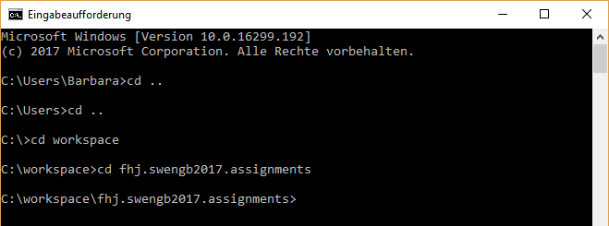

►Now, start SBT by typing in "sbt" and press "ENTER" again - select current project "XXXXXX"

► Insert "run" and press "ENTER" again.

► Now, the Battleship Game should start and you should see the Splash Screen while the application is loading.

## 4.2 Welcome Screen

Now you have the choice between an amount of Buttons. For example:

► Start Game: -   
► Show Highscore: -  
► Show Credits: -   
► Mute: -

### 4.2.1 Mute

If you click on this button the sound will be disabled. By clicking this button again the sound will be enabled.

### 4.2.2 Credits

On this screen you will get an overview who was involved in this project and further information regarding to the project. If you want to return to the "Welcome Screen" there is a "Return-Button" available.

### 4.2.3 Highscore

After you have finished a game you can save your game details - For example, how many steps PlayerA or PlayerB needed to win the game or what the game name was and when the game was played and so on.

It is also possible to replay each game by clicking "REPLAY". It enables you to review an already played game. Additional Buttons like "RETURN TO MAIN" and "CLEAR HIGHSCORE?" are also available to change to the specified screen. "CLEAR HIGHSCORE" will delete your current Highscore.

An Additional feature by clicking the "REPLAY" buttons is, that you have an implemented slider which shows you the history of one game. So what happened in which round.

### 4.2.4 Start Game

On this screen there are several buttons available to modify the game.

► New Game  
► Load Game  
► Save Game

# STAGES REMASTERED

## Start Screen

There are certain stages in the game. The first stage is the start screen of the app. From there you can see a nice picture with a start button, which you can press to eventually come to the main menu.

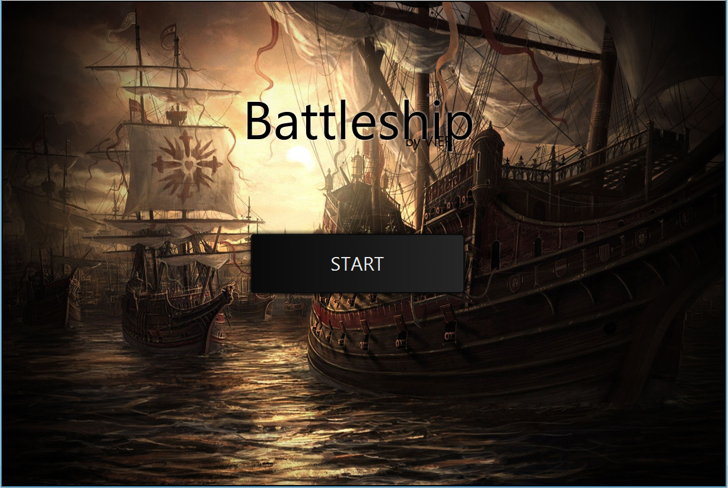

## Main Menu

Then there is the main menu. The main menu consists of four buttons. There you can either start a new game, join an existing game, show the highscore or the credits.

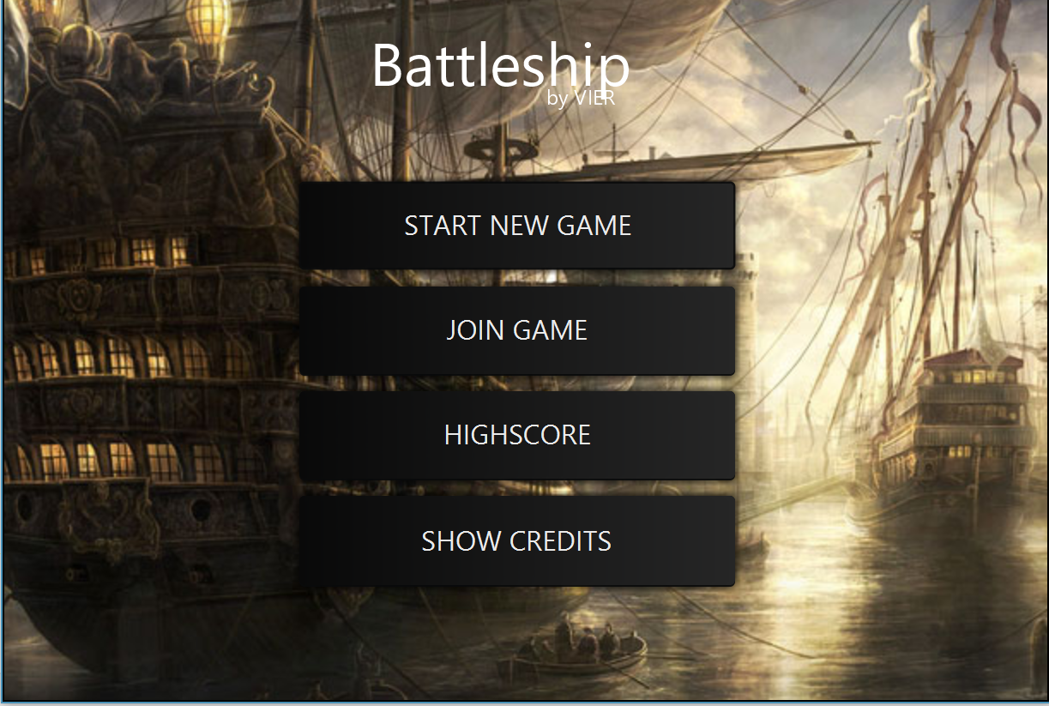

## Enter your Name – Screen

After starting a new game, the enter your name screen is where you enter the name of your player. Confirm and you will get to the loading screen.

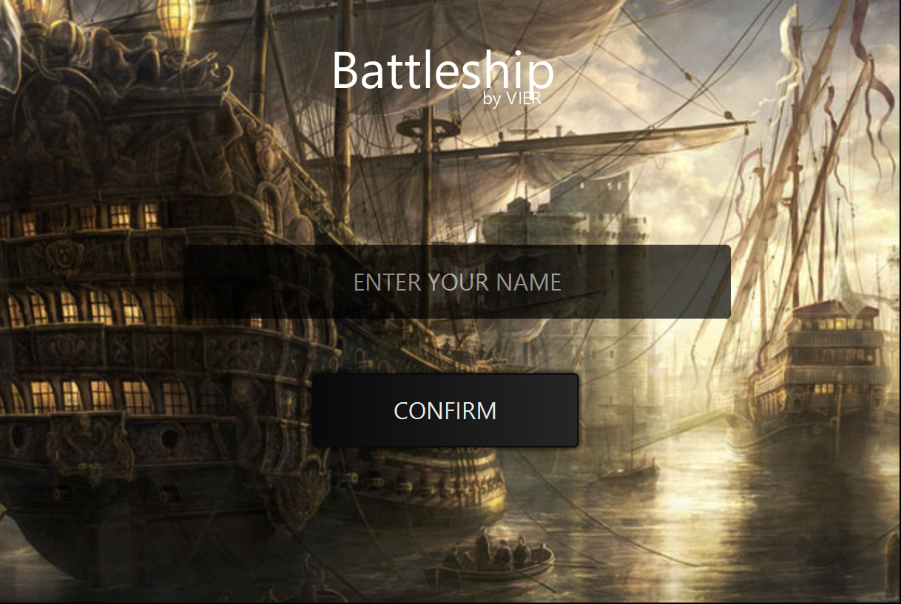

## Loading Screen

The loading screen turns up and a connection either to the local host or to the ip address you specify in a network is being established.

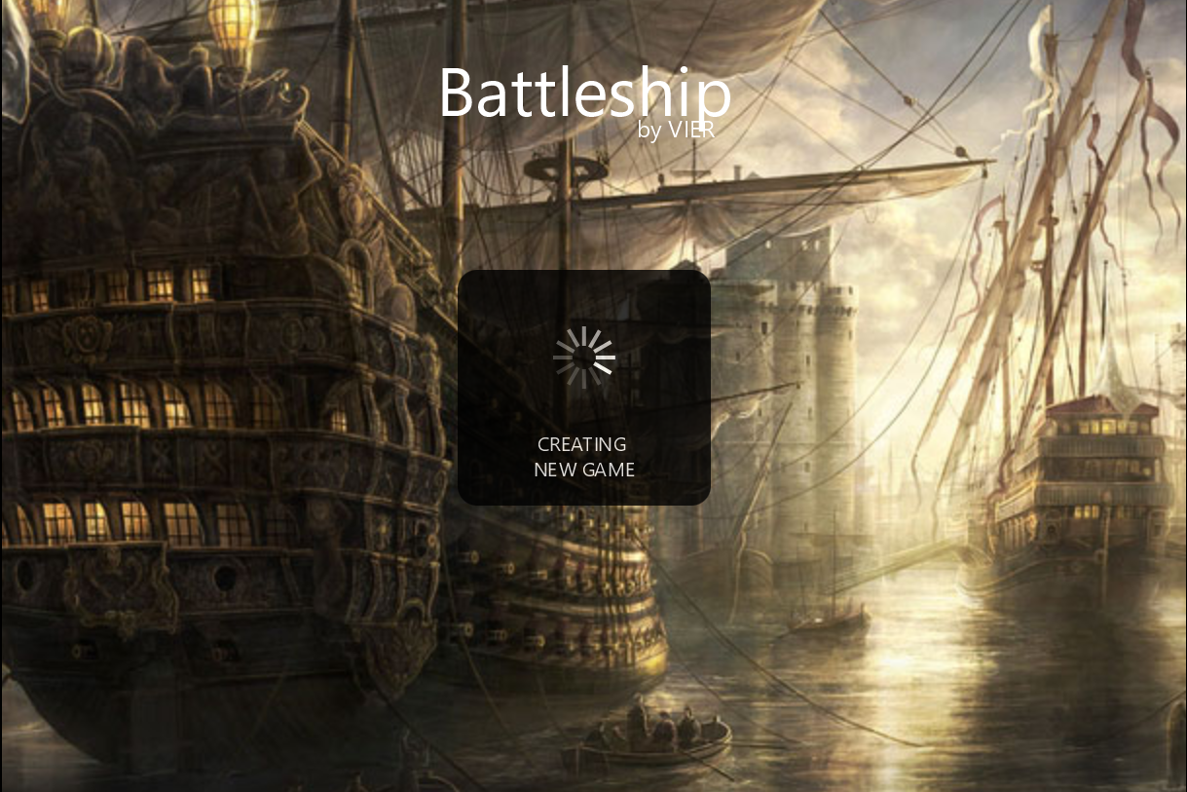

## Server-Connection – Error – Screen

If you fail to connect, you get the server-connection -Error-screen. This can either be because there is some error with the IP setting or you finish the placing of the fleet in the Battle-Screen before the other player has connected. Then the server won´t be able to detect player 2 anymore. Be sure to close both tabs of the game in intellij simultaneously and wait for 20 seconds if you want to start another game. Otherwise there will be complications, because it takes some time to release the ports.

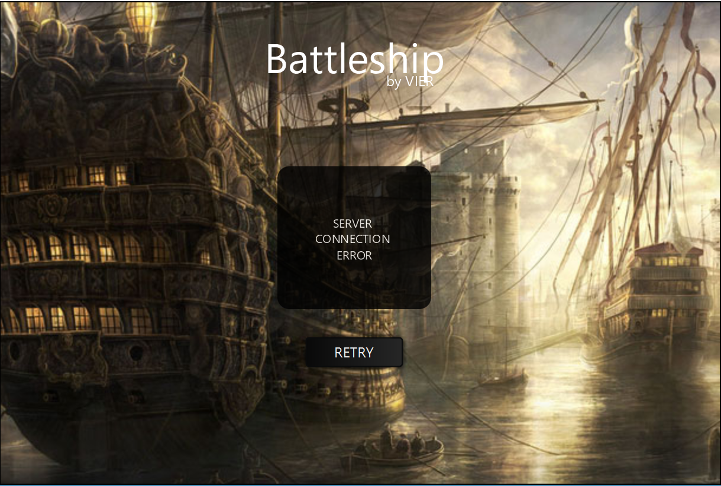

# Battle-Screen and Edit Mode

The battle screen is the real deal. There the ultimate fight begins. The edit mode just looks like the battle-screen, but with some alterations. In the edit mode you can place ships. You drag them from the pane in the middle of the screen. You can choose between a different set of battleships, which vary in size on the battlefield pane. Click on the ship you want to place and the ship displayed as the amount of fields on the pane will follow your cursor dynamically. You can alter the orientation of your ship by clicking right. if you are done, the client sends the notification to have set all the ships to the other client and the enemy battlefield pane is locked now from each other´s sight. If you are player 1, you can´t see player 2´s ships, vice versa. You can start to shoot and the field corresponds to whose player´s turn it is by shining white on the borders. The game is over, when all ships are sunk.

The battle begins. Have fun and enjoy! Wreck the enemy!

